|  |  |
| --- | --- |
|  |  |

**eProject Document**

ASKME-MOBILE

|  |  |
| --- | --- |
| **Group 5** | |
| **Members** | Mac Duy Thanh – Student1253302  Nguyen HuyHoang – Student1240567  Nguyen Thi Binh – Student1247034  Lai Thi Hanh – Student1247028 |
| **Instructor** | Nguyen Van Luan |
| **Batch** | C1908I1 |
| **Semester** | I |

**🙠 Date of issue 09-13-2013 🙢**

**Table of Content**

1. **Problem definition**
   1. ***Introduction***
   2. ***Existing Scenario***
2. **Acknowlegements**
3. **Project Synopsis**
4. **Project Analysis**
5. **Project Design**
   1. ***DFD’s***
   2. ***FlowCharts***
   3. ***Process Diagrams***
   4. ***Database Desin / Struture***
6. **Sreen Shot’s**
7. **Source Code With Comments**
8. **User Guide**
9. **Developer’s Guide**
   1. ***Module Descriptions***
10. **Problem Definition**
    1. **Introduction**

* Mobile Communication System is an organization system that provides two services like the telecommunications and Internet Services.
* It has now extended its service all over the territory due to the increase in demand for the internet service.
* They have opened the retail shops at each place so that increase the comfort level of the customers where the customers can make the payment, also they can place an order or enquire for a new connection by directly visiting to the retail shops at their place in that city, instead of applying at the office at their city.
  1. **Existing Scenario**
* As the demand of customers using mobile is increasing, the company has expanded its services throughout the territory and even started the retails stores everywhere, as well as to increase the comfort level of customers can make payments, place orders, request information of a connection.
* The company also has promotional mode for those potential customers who have large numbers of contracts connected with the company. They will be discounted by the applicable option: 10-15 connections they will receive 25% discount as well in advance and the security deposit, they will take advantage of 15-25 50% discount, 25-50 they will take advantage of 75% and over 50 they will get 100% discount.
* Customer information is stored, including payments (Monthly rentals, Security Deposit, dues if any, etc…), based on signed contracts (for broadband and dial-up connection), customers will be provided with equipment (Modem or Router). Besides personal information of customers will also be archived.
* The details of the product manufacturing vendors are maintained along with the orders placed, payment lists, name and contact details are maintained. So it includes huge amount of paper work as a whole, due to which slip ups take place.
* All information about customer records, as well as a list of product providers are stored in large quantities of work papers. So easy error occurred.   
  The detail of the equipment (stock), employees, vendors are maintained and updated solely by the Admin (Manager). They also maintain the list of the applications for the connection, some customers try to change their plan, and as well some gets connection but some don’t due to the feasibility reports, etc.

1. **Asknowlegements**

* The project would like to thank bachkhoa-aptech Information Technology Training System for creating good conditions for our group to implement this sem I projcet well.
* We would like to express our sincere thanks to the teachers inbachkhoa-aptech Information Technology Traning System who have devotedly taught and equipped the group with valuable knowledge during the past school days, helping the group have a foundation. Solid knowledge to complete this project. Specially, our team would like to express our sincere thanks to the enthusiastic

guidance and suggestions of Mr.Nguyen Van Luan for helping the projcet team successfully complete this sem I project.

* Although the research team has tried to complete the graduation projcet within the scope and ability, it is definitely inevitable. The project team hopes to receive sympathy and whole-hearted contribution of teachers.

1. **Project Synopsis**

* With the complexity and scale application, plus be a matter of time for the project “ Construction mobile website” stands at just learn a web programming language HTML5 & JavaScript and application of experimental applications of web-based sales website to mobile shops.
* Website for the purpose of providing its client with accurate information about the mobile products are available on the market and how to order goods online. The information is updated regularly and quickly. Thus, shortening the distance between buyers and sellers, provide information on new products quickly to customers.
* Because there are some limitations, should stop at the new site features view products and ordering. In the future, the system will evolve in the direction of electronic commerce (in the form of online payment thought credit cards, bank accounts, online shopping cart …). Due to limitations in the presentation should be written this paper, I just would like to present some important processes, from surveys, to analyze, design, install the system. Look forward to your understandind and your Teacher.

<https://www.slideshare.net/thanhnd28071/phn-tch-thit-k-h-thng-ca-hng-bn-in-thoi-di-ng>

1. **Customer Requirement Specification**
   1. **Customer Requirement**
      1. **Users of the system**

* Admin
* Accountant
* Technician
  + 1. **System functions**

|  |  |
| --- | --- |
| **User** | **Functions** |
| **All Users** | * Login * Change Profile |
| **Admin** | * Employee management * Vendor management * Retail shops management * Plan management * Equipment (stock) management * Levy management * View List Bills * View List Customers * View List Orders |
| **Accountant** | * View Plan * Feedback * Order manager,… |
| **Technician** | * Change profile,…. |

* 1. **Common functions**

|  |  |
| --- | --- |
| **Login** | |
| Input | Login to system, user must be enter username and password |
| Process | Access information in database |
| Output | Result of login |
| **Change Profile** | |
| Input | Information details of user such as Name, Address, Phone, Email … |
| Process | Maintain user’s information details |
| Output | Result of Change profile |

* 1. **Admin functions**

|  |  |
| --- | --- |
| **Employee management** | |
| Input | Information details of employee such as ID, Name, Birthday, Email, Address, Phone, Role, Description … |
| Process | Access information in database to modify, add new employee to database, delete from database. |
| Output | Display or maintain Information detail of Employee. |
| **Vendor management** | |
| Input | Information details of Vendor such as Name, Address, Phone, Fax, Email, Description … |
| Process | Access information in database to modify, add new vendor to database, delete from database. |
| Output | Display or maintain Information detail of Vendor. |
| **Retail shops management** | |
| Input | Information details of Retail shop such as Name, Address, City, Phone, Email, Description … |
| Process | Access information in database to modify, add new Retail shop to database, delete from database. |
| Output | Display or maintain Information detail of Retail shop. |
| **Plan management** | |
| Input | Some information details of plan which want to edit or view |
| Process | Access information in database |
| Output | Display or maintain Information detail of plan. |
| **Equipment (stock) management** | |
| Input | Information details of Equipment such as Name, Type, Vendor, Price, warranty, Description… |
| Process | Access information in database to modify, add new equipment to database, delete from database. |
| Output | Display or maintain Information detail of equipment. |
| **Levy management** | |
| Input | Information details of Levy such as Name, value, Description… |
| Process | Access information in database to modify, add new levy to database, delete from database. |
| Output | Display or maintain Information detail of levy. |
| **View List Bills** | |
| Input | View List Bills. |
| Process | Find the bill by Order ID or customer name in database |
| Output | Display list Bills. |
| **View List Customers** | |
| Input | View List Customers. |
| Process | Find customer by Customer ID or customer name in database. |
| Output | Display the list customers. |
| **View List Orders** | |
| Input | View List Orders |
| Process | Find the bill by Order ID or customer name in database |
| Output | Display the list Orders. |

* 1. **Customer functions**

|  |  |
| --- | --- |
| **Place an order** | |
| Input | Customer fills required information: type of connection, area, name, Social Number Identification, address, email, equipment, etc… |
| Process | Send requirement to system. |
| Output | Result of send. |
| **View the bill of him/her** | |
| Input | View the bill |
| Process | Find the bill in database |
| Output | Display detail of bill |
| **Search the order status of him/her** | |
| Input | Customer fills appropriate information to search. |
| Process | Find the order in database. |
| Output | Display the result. |
| **Keep track connection of him/her** | |
| Input | Search connection status with Customer ID. |
| Process | Find the connection in database. |
| Output | Display connection status. |
| **Feedback** | |
| Input | Information which send to company. |
| Process | Maintain the information to database |
| Output | Result of feedback |

* 1. **Retail shop functions**

|  |  |
| --- | --- |
| **View all orders status** | |
| Input | Fill appropriate information to search order status. |
| Process | Find the order in database. |
| Output | Display the result. |
| **Search order** | |
| Input | Fill appropriate information to search |
| Process | Find the order in database |
| Output | List of order |
| **Place order, Maintain Order** | |
| Input | Fills required information: type of connection, area, name, Social Number Identification, address, email, equipment, etc… |
| Process | Maintain order status details |
| Output | Order was maintained in database |
| **View List Customers** | |
| Input | View List Customers |
| Process | Find customer by Customer ID or customer name in database |
| Output | Display the list customers |

* 1. **Accountant functions**

|  |  |
| --- | --- |
| **View List Bills** | |
| Input | View List Bills. |
| Process | Find the bill by Order ID or customer name in database. |
| Output | Display list Bills. |
| **Generate bills** | |
| Input | Generate bills for Customers every month. |
| Process | System automatic calculated to generate the bill. |
| Output | Send bill to customer’s email and maintain the bill in database. |
| **Update status of bills** | |
| Input | Update status of bill for customer |
| Process | Find the bill by Order ID or customer name in database to update. |
| Output | Status of bill was updated |

* 1. **Technician functions**

|  |  |
| --- | --- |
| **Keep track list orders** | |
| Input | View all orders |
| Process | Find the orders in database |
| Output | Display list orders |
| **Update order status** | |
| Input | Status of order which want to modify |
| Process | Find the order in database to update status |
| Output | Order status was updated |
| **Create new connection** | |
| Input | Information of connection such as type, information of customer… |
| Process | Maintain new connection to database. |
| Output | Result of create new connection |
| **Change the type of connection for order (Dial –up or Broad Band, Land Line…)** | |
| Input | Type of connection |
| Process | Find the connection in database which want to change. |
| Output | Result of change. |

* 1. **Hardware – Software requirement**

### Minimum Hardware Requirements

* CPU: Pentium IV 2.00 GHz.
* RAM: 512 MB.
* Hard Disk: 5 GB.
* OS: Window 2000/XP/Server 2003.

### Recommended Hardware Requirements

* CPU: Dou Core 2.00 GHz or higher.
* RAM: 2 Gb or higher.
* Hard Disk: 80 GB or higher.
* OS: Window XP SP3 / Window 7

### Software Requirements

* Environment: Microsoft .NET Framework 2.0 or later
* Database Management System: Microsoft SQL Server 2005 or later
* IDE: Microsoft Visual Studio 2008 or later
* Web Server: Internet Information Services (IIS 7.0) or later

1. **Architecture and design of the system**

The Application will be made of a Web-based distributed three-tier architecture.

User Interface with HTML

Web - Tier

And ASPX pages

Middle Tier

C# (Code - behind) file containing

business logic

Database - Tier

SQL Server 2008

**Web – based distributed 3 - Tier Architecture of the Project**

1. **Flow chart**
   1. **Login**

Start

Start

Display confirm exit

Input data

Check Data

Display Error

**false**

Logout

**true**

Stop

Successful login

b. System Logout

Stop

1. System Login
   1. **Add / Update Data**

Start

Start

Load data

Input Data

**false**

Display error

Input Data

Display error

Check Data

**true**

Check Data

Save database

**false**

**true**

Save database

Display messenger

Display messenger

Stop

1. Add data

Stop

b. Update data

* 1. **Search data**

Start

Input keyword

Display error

Check data

**false**

**true**

Display result

Stop

* 1. **Delete Data**

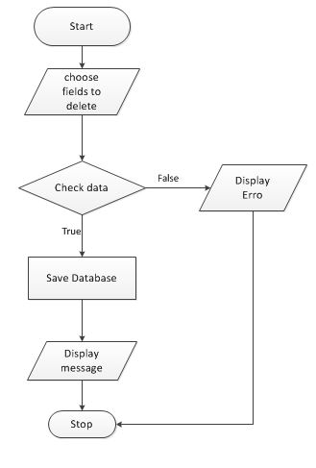

1. **Data flow diagram**
   1. **General Diagram**

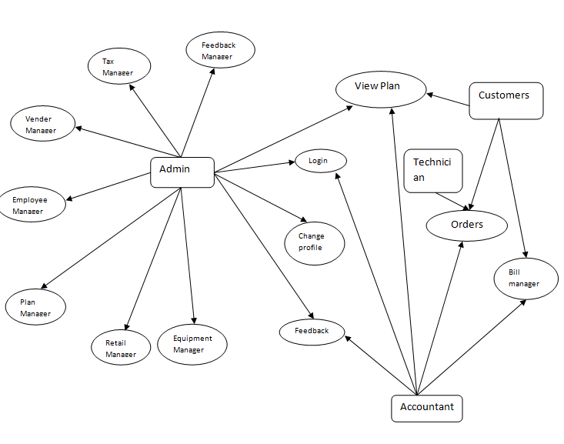

* 1. **Use case**

1. Login

Accountant

Technician

Admin

Users

1. Change Profile

Customer

Customer

Customer

Users

1. Employee Management

Employee

Admin

1. Search

Users

1. Plan Management

Plan Manager

Admin

1. Vender Management

Vender Manager

Admin

1. Retail Shop Management

Retails Man..

Admin

1. Equipment Management

Equipment

Admin

1. Tax Management

Tax Man..

Admin

1. View Orders

Customers

Users

1. Bill Management

Bill Manager

Accountant

1. Feedback

Accountant

Admin

1. Feedback Management

Admin

1. **Entity relationship diagram**
   1. **Entity relationship diagram**

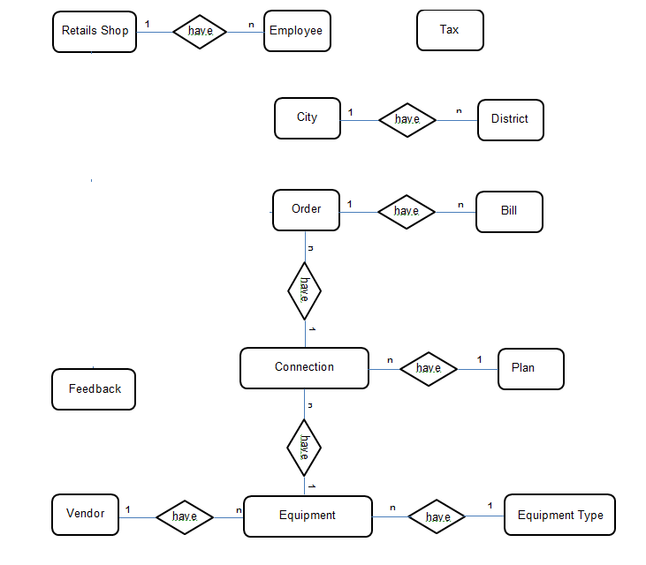

* 1. **Entity - Attributes**

**Bill**











**District**







**FeedBack**



**Orders**







1. **Database Design/Structure**
   1. **Database relationship diagram**

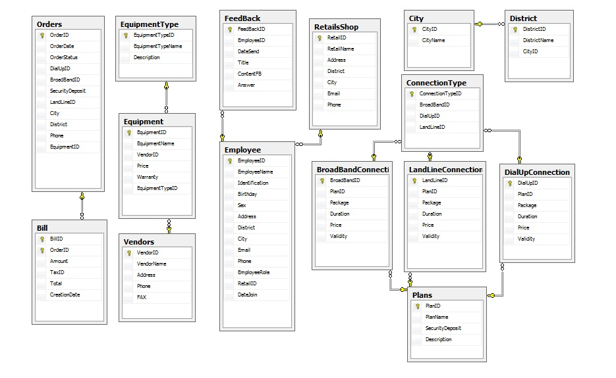

* 1. **Table Design**

|  |  |  |  |  |
| --- | --- | --- | --- | --- |
| **Table:BroadBandConnection** | | | | |
| **Column** | **Data type** | **Allow Nulls** | **Key** | **Description** |
| BroadBandID | Varchar(20) | 🞎 | PK | ID of Broad Band Connection |
| PlanID | Int | 🞎 | FK | ID of Plan |
| Package | Varchar(20) | 🞎 |  | Package of Broad Band Connection |
| Duration | Varchar(20) | 🞎 |  | Duration of Broad Band Connection |
| Price | Float | 🞎 |  | Price of Broad Band Connection |
| Validity | Varchar(20) | 🗹 |  | Validity of Broad Band Connection |

|  |  |  |  |  |
| --- | --- | --- | --- | --- |
| **Table:City** | | | | |
| **Column** | **Data type** | **Allow Nulls** | **Key** | **Description** |
| CityID | Varchar(20) | 🞎 | PK | ID of CiTy |
| CityName | Varchar(50) | 🞎 |  | Name of District |

|  |  |  |  |  |
| --- | --- | --- | --- | --- |
| **Table:DialUpConnection** | | | | |
| **Column** | **Data type** | **Allow Nulls** | **Key** | **Description** |
| DialUpID | Varchar(20) | 🞎 | PK | ID of Dial Up Connection |
| PlanID | Int | 🞎 |  | ID of Plan |
| Package | Varchar(20) | 🞎 |  | Package of Dial Up Connection |
| Duration | Varchar(20) | 🞎 |  | Duration of Dial Up Connection |
| Price | Float | 🞎 |  | Price of Dial Up Connection |
| Validity | Varchar(20) | 🗹 |  | Validity of Dial Up Connection |

|  |  |  |  |  |
| --- | --- | --- | --- | --- |
| **Table:District** | | | | |
| **Column** | **Data type** | **Allow Nulls** | **Key** | **Description** |
| DistrictID | Varchar(20) | 🞎 | PK | ID of District |
| DistrictName | Varchar(50) | 🞎 |  | Name of District |
| CityID | Varchar(20) | 🞎 | FK | ID of City |

|  |  |  |  |  |
| --- | --- | --- | --- | --- |
| **Table: Employee** | | | | |
| **Column** | **Data Type** | **Allow Nulls** | **Key** | **Description** |
| EmployeeID | varchar(20) | 🞎 | PK | ID of Employee |
| EmployeeName | varchar(50) | 🞎 |  | Name of Employee |
| Identification | Varchar(20) | 🞎 |  | Identification of Employee |
| Birthday | datetime | 🞎 |  | Birthday of Employee |
| Sex | Varchar(10) | 🞎 |  | Sex of Employee |
| Address | text | 🞎 |  | Address of Employee |
| District | Varchar(20) | 🞎 |  | District of Employee |
| City | Varchar(20) | 🞎 |  | City of Employee |
| Email | varchar(50) | 🗹 |  | Email of Employee |
| Phone | varchar(20) | 🗹 |  | Phone of Employee |
| EmployeeRole | varchar(20) | 🗹 |  | Role of Employee |
| RetailID | varchar(20) | 🞎 | FK | ID of Employee |
| DateJoin | datetime | 🞎 |  | Date join of Employee |

|  |  |  |  |  |
| --- | --- | --- | --- | --- |
| **able: Equipment** | | | | |
| **Column** | **Data type** | **Allow Nulls** | **Key** | **Description** |
| EquipmentID | varchar(20) | 🞎 | PK | ID of Equipment |
| EquipmentName | varchar(50) | 🞎 |  | Name of Equipment |
| VendorID | varchar(20) | 🞎 | FK | ID of Vendor |
| Price | float | 🞎 |  | Price of Equipment |
| Warranty | Int | 🞎 |  | Warranty of Equipment |
| EquipmentTypeID | Int | 🞎 | FK | Type of Equipment |

|  |  |  |  |  |
| --- | --- | --- | --- | --- |
| **Table:EquipmentType** | | | | |
| **Column** | **Data type** | **Allow Nulls** | **Key** | **Description** |
| EquipmentTypeID | Int | 🞎 | PK | ID of Equipment Type |
| EquipmentTypeName | Varchar(50) | 🞎 |  | Name of Equipment Type |
| Description | Varchar(100) | 🗹 |  | Description of Equipment Type |

|  |  |  |  |  |
| --- | --- | --- | --- | --- |
| **Table: Feedback** | | | | |
| **Column** | **Data type** | **Allow Nulls** | **Key** | **Description** |
| FeedBackID | int | 🞎 | PK | ID of Feedback |
| EmployeeID | varchar(20) | 🞎 | FK | ID of Employee |
| DateSend | datetime | 🗹 |  | Date Send of Feedback |
| Title | varchar(50) | 🞎 |  | Title of Feedback |
| ContentFB | text | 🞎 |  | Content of Feedback |
| Answer | text | 🗹 |  | Answer FeedBack |

|  |  |  |  |  |
| --- | --- | --- | --- | --- |
| **Table:LandLineConnection** | | | | |
| **Column** | **Data type** | **Allow Nulls** | **Key** | **Description** |
| LandLineID | Varchar(20) | 🞎 | PK | ID of Land Line |
| PlanID | Int | 🞎 | FK | ID of Plan |
| Package | Va | 🞎 |  | Package of LandLineConnection |
| Duration | Varchar(20) | 🞎 |  | Duration of LandLineConnection |
| Price | Float | 🞎 |  | Price of LandLineConnection |
| Validity | Varchar(20) | 🗹 |  | Validity of LandLineConnection |

|  |  |  |  |  |
| --- | --- | --- | --- | --- |
| **Table: Orders** | | | | |
| **Column** | **Data type** | **Allow Nulls** | **Key** | **Description** |
| OrderID | int | 🞎 | PK | ID of Order |
| OrderDate | datetime | 🞎 |  | Order Date of Order |
| OrderStatus | varchar(20) | 🞎 |  | Status of order |
| DialUpID | varchar(20) | 🗹 | FK | ID of Dial Up |
| BroadBandID | varchar(20) | 🗹 | FK | ID of Broad Band |
| SecurityDeposit | float | 🗹 |  | Security Deposit of Order |
| LandLineID | varchar(20) | 🗹 | FK | ID of Land Line |
| City | varchar(20) | 🞎 | FK | City |
| District | varchar(20) | 🞎 |  | District |
| Phone | float | 🞎 |  | Phone |
| EquipmentID | varchar(20) | 🗹 |  | ID of Equipment |
| passport | Float | 🞎 |  | Passportcustomers |
| Name | Nvarchar(20) | 🞎 |  | Name customers |

|  |  |  |  |  |
| --- | --- | --- | --- | --- |
| **Table: Plans** | | | | |
| **Column** | **Data type** | **Allow Nulls** | **Key** | **Description** |
| PlanID | int | 🞎 | PK | ID of Plan |
| PlanName | varchar(20) | 🞎 |  | Name of Plan |
| SecurityDeposit | float | 🞎 |  | Deposit Security of Plan |
| Description | text | 🗹 |  | Description of Plan |

|  |  |  |  |  |
| --- | --- | --- | --- | --- |
| **Table: Retail Shop** | | | | |
| **Column** | **Data type** | **Allow Nulls** | **Key** | **Description** |
| RetailID | varchar(20) | 🞎 | PK | ID of Retail Shop |
| RetailName | varchar(50) | 🞎 |  | Name of Retail Shop |
| Address | text | 🞎 |  | Address of Retail Shop |
| Email | varchar(50) | 🞎 |  | Email of Retail Shop |
| Phone | varchar(20) | 🞎 |  | Phone of Retail Shop |
| District | varchar(20) | 🞎 |  | District of Retail Shop |
| City | varchar(20) | 🞎 |  | City of Retail Shop |

|  |  |  |  |  |
| --- | --- | --- | --- | --- |
| **Table: Vendors** | | | | |
| **Column** | **Data type** | **Allow Nulls** | **Key** | **Description** |
| VendorID | varchar(20) | 🞎 | PK | ID of Vendor |
| VendorName | varchar(50) | 🞎 |  | Name of Vendor |
| Address | text | 🞎 |  | Address of Vendor |
| FAX | varchar(20) | 🗹 |  | FAX of Vendor |
| Phone | varchar(20) | 🞎 |  | Phone of Vendor |

1. **Some typical interface**

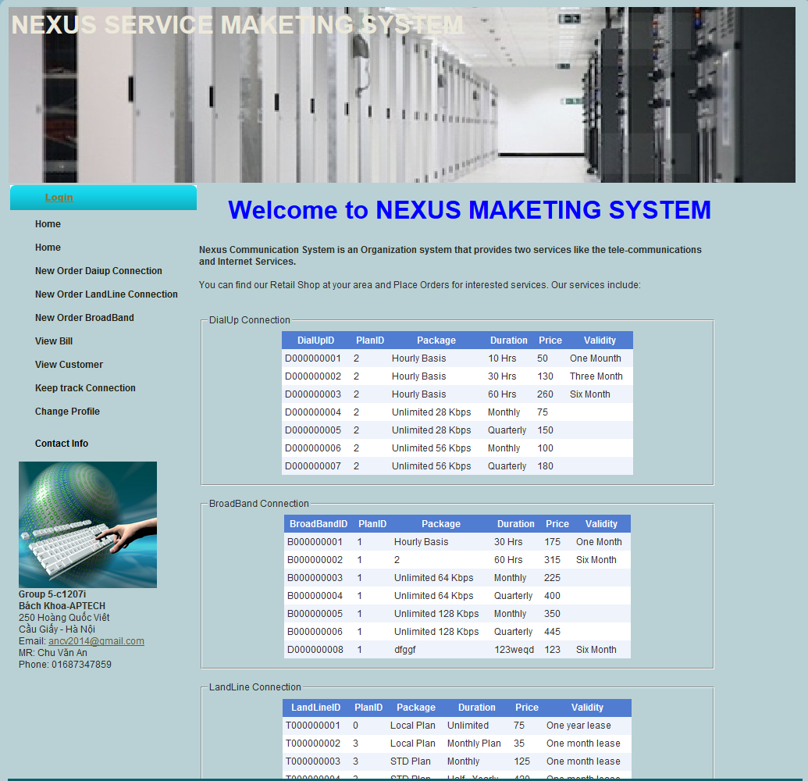

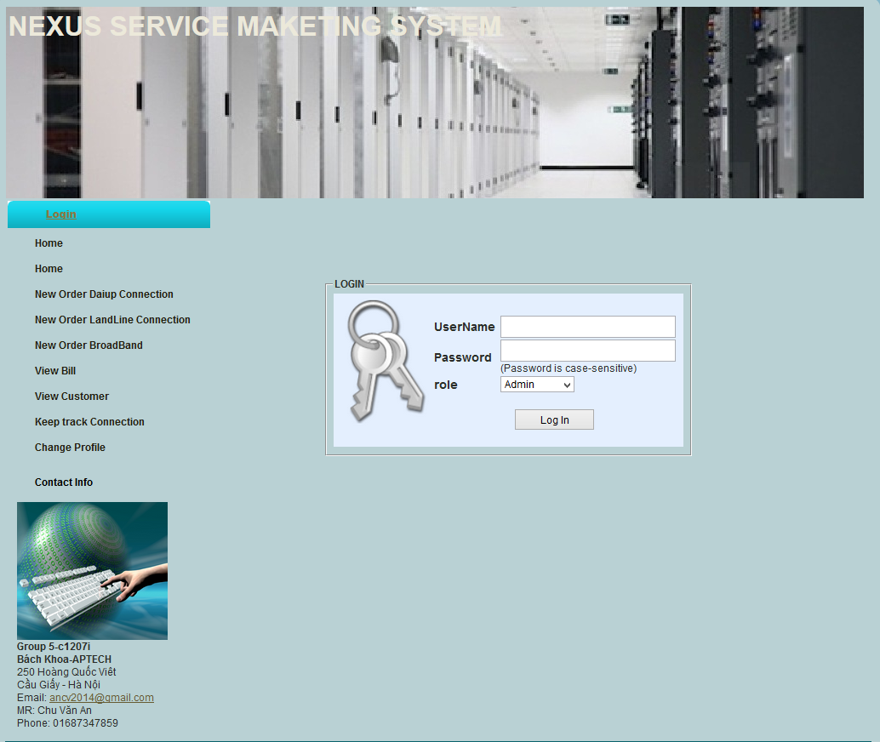

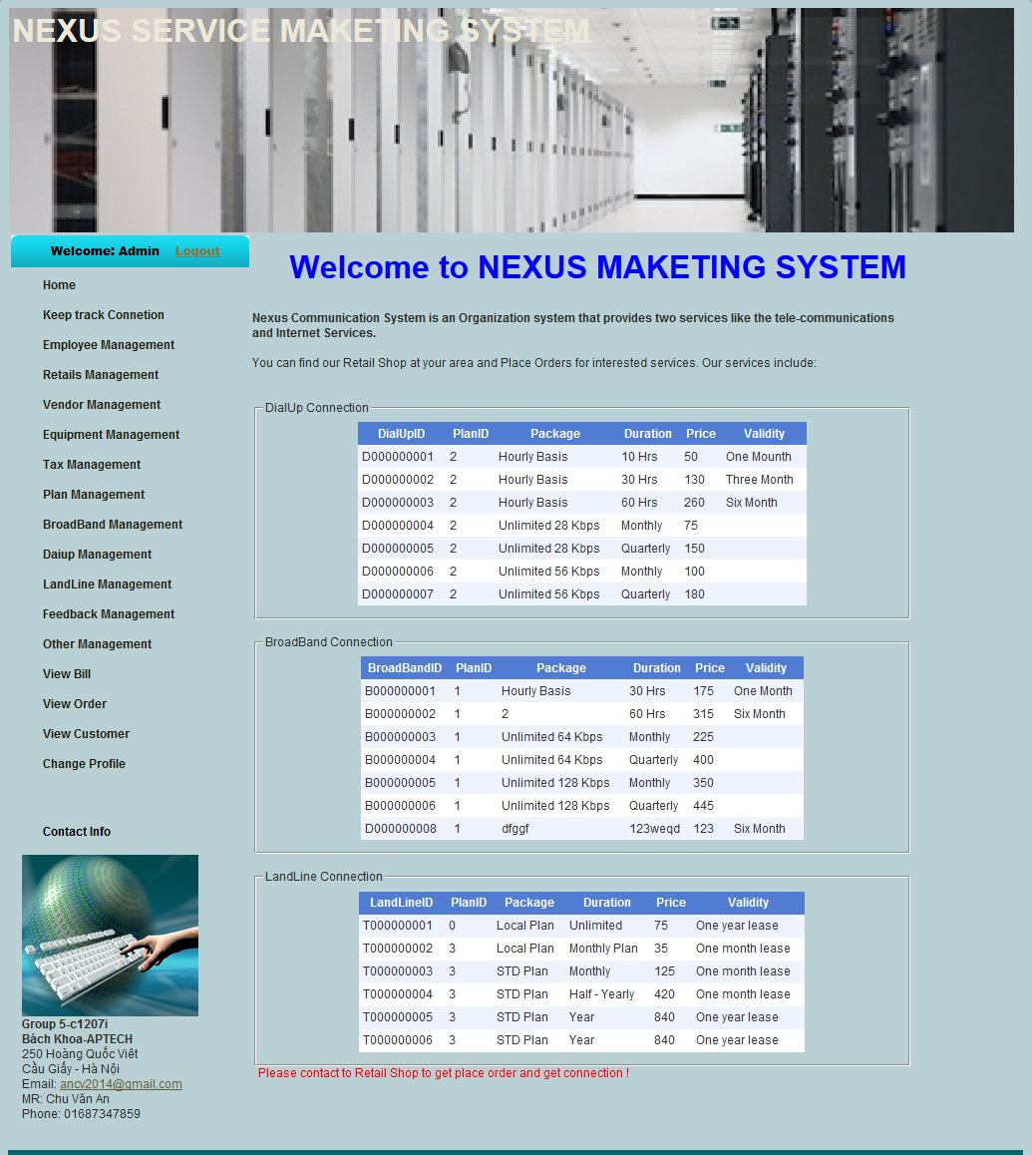

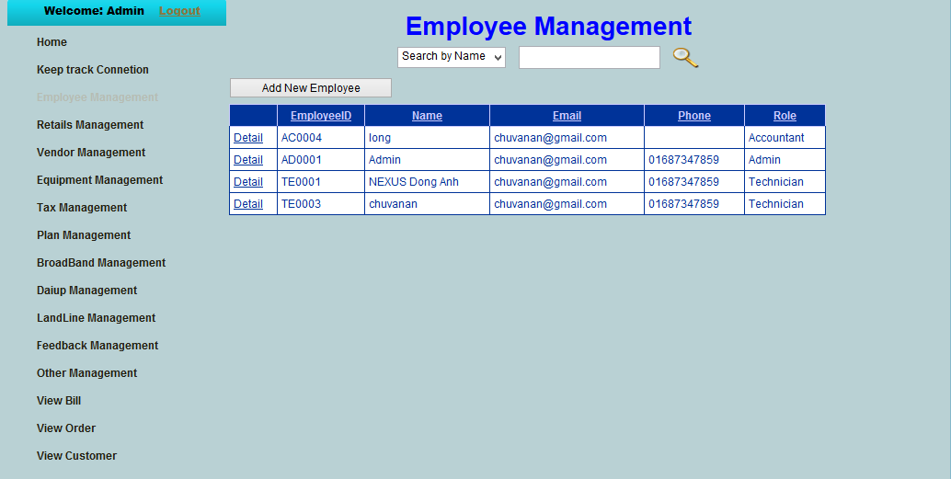

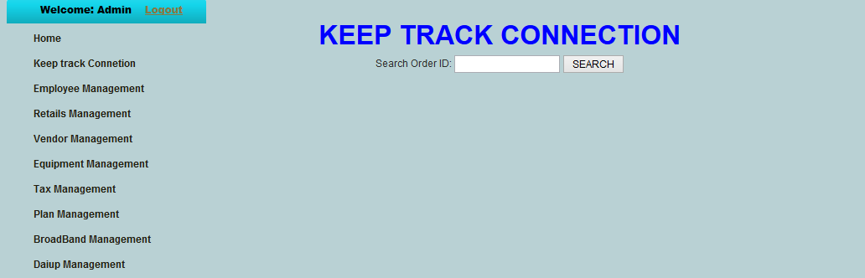

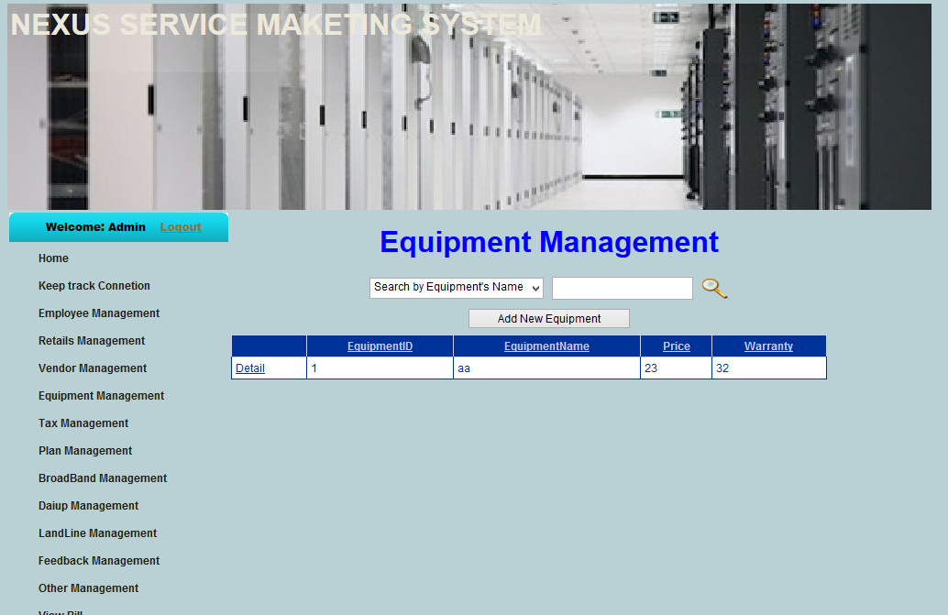

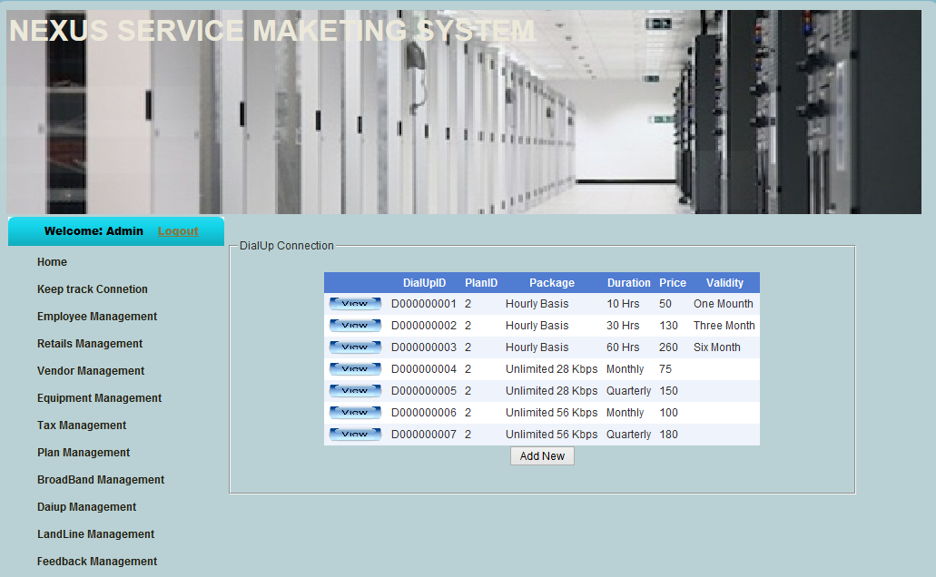

1. **Task Sheet**

|  |  |  |  |  |  |  |
| --- | --- | --- | --- | --- | --- | --- |
| **Project Ref. No: 1** | | Project Title: Nexus Service Marketing System | **Date of Preparation of Activity Plan** | | | |
| **Sr. No.** | **Task** | | **Actual Start Date** | **Actual Days** | **Team Member Names** | **Status** |
| 1 | Problem definition | |  | 7 | Tran Quoc Long | complete |
| 2 | User of system | | Tran Quoc Long | complete |
| 3 | System Functions | | Tran Quoc Long | complete |
| 5 | Admin functions | | Chu Van An | complete |
| 6 | Customer functions | | Chu Van An | complete |
| 7 | Retail shop functions | | Chu Van An | complete |
| 8 | Accountant functions | | Nguyen Ba Son | complete |
| 9 | Technician functions | | Tran Quoc Long | complete |
| 10 | Hardware and Software Requirements | | Le Thanh Hop | complete |
| 11 | Login.aspx | |  | 13 | Chu Van An | complete |
| 12 | AddNewEmployee.aspx | | Chu Van An | complete |
| 13 | AddNewEquipment.aspx | | Chu Van An | complete |
| 14 | AddNewRetailShop.aspx | | Chu Van An | complete |
| 15 | AddNewTax.aspx | | Chu Van An | complete |
| 16 | AddNewVendor.aspx | | Chu Van An | complete |
| 17 | BillManagement.aspx | | Le Thanh Hop | Not complete |
| 18 | ChangeProfile.aspx | | Chu Van An | complete |
| 19 | MainPage.aspx | | Nguyen Ba Son | complete |
| 20 | PayBill.aspx | | Le Thanh Hop | Not Complete |
| 21 | Some other…..etc.. | |  |  | Chu Van An | Not complete |

1. **Check list of validation**

|  |  |
| --- | --- |
| Option | Validate |
| Can a new user who get registered, enter the application after logging in ? | Yes |
| Do all the option present in the application display the correct result | Yes |
| Does the application’s functionality resolve the user problem and satisfy their needs ? | Yes |
| Has the hardware and software been correctly chosen ? | Yes |

1. **Submission checklist**

|  |  |  |  |  |
| --- | --- | --- | --- | --- |
| Sr.No | Particular | Yes | No | Comments |
| 1 | Are the users able to login to application after validations is performed on the on the user name and password ? | Yes |  |  |
| 2 | Are the user able to modify their detail after getting registered | Yes |  |  |
| 3 | Are all the screen contents devoid spelling mistakes | Yes |  |  |
| 4 | Is the application user-friendly | Yes |  |  |

**THE END**